Force for the Future: Daikin’s revolutionary Daikin Altherma 3 Low Temperature Split Series expanded

Daikin is to expand its Daikin Altherma 3 low temperature split series with the launch of the ECH2O integrated pressureless floor standing indoor units.

Powered by Daikin’s advanced Bluevolution technology, the Daikin Altherma 3 Series combines high efficiency compressors with the low GWP R32 refrigerant. The refrigerant of the future, R32 offers a more sustainable alternative to HCFCs with equivalent performance.

Available from this summer, the new integrated ECH2O model offers installers and homeowners increased choice and maximises the use of renewable energy. Combining high performance with ease of installation, the ECH2O incorporates features unique to the market, such as fresh water principle, providing domestic hot water without the risk of contamination and sedimentation.
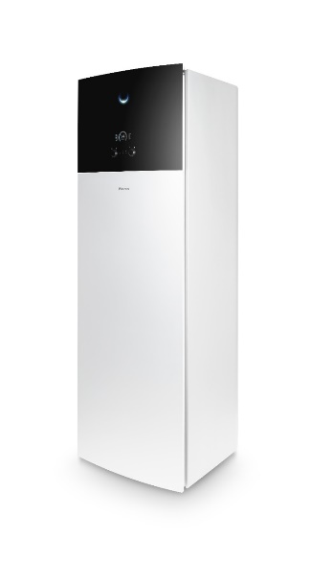
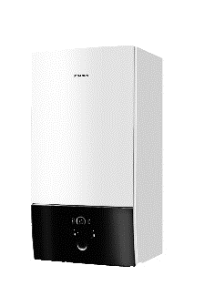
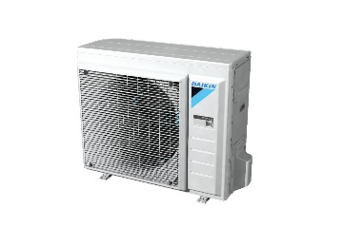
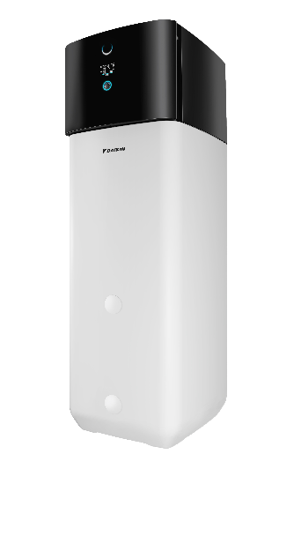

Daikin Altherma 3 split series expanded
The integrated ECH₂O unit joins the Daikin Altherma 3 product range. Using R-32 Bluevolution technology, the range is equipped with our innovative user interface featuring the Daikin Eye.

High performance
Daikin Altherma are the most sold heat pump systems in Europe, with over 500,000 systems delivered to date. Powered by Daikin’s unique Bluevolution technology, the new R32 Daikin Altherma 3 series offers users higher capacities, with a 65°C leaving water temperature, making it perfect for new build applications using underfloor heating, while offering the required heating performance in radiator applications. without the need for electric immersion heater support.
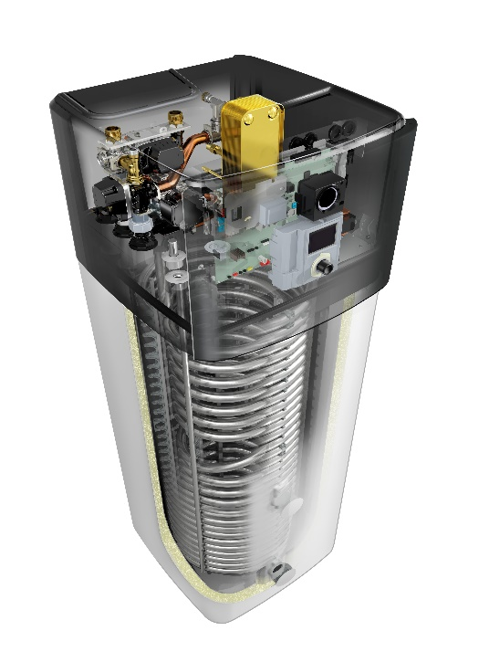
Intuitive user interface
Easy to configure, the intuitive Daikin Eye provides a visual update on the status of your system in real time. Blue indicates the system is performing perfectly. Should an error occur, the Eye will turn red.

ECH2O technology – the fresh water principle
The separation of the water in the tank from domestic hot water ensures fresh clean water, with no risk of contamination and sedimentation.

Maximising renewable energy use
As an environmentally friendly heat pump, the integrated ECH₂O unit offers a future-proof solution using solar energy. The unit is available as either a pressurized solar system, connected to thermal solar panels, and filled with heat transfer fluid combined with an antifreeze or a pressureless system fitted with an additional pump which circulates the water in the system without the need for antifreeze. A third, bivalent option, allows heat from other sources such as oil, gas or pellet-fired boilers to be stored in the solar systems, further lowering energy consumption. Systems come with a Smart Grid Ready function, which allows the unit to be connected to photovoltaic solar panels.
Designed for efficiency and versatility
The new Daikin Altherma 3 ECH₂O indoor unit EHS(B)(H/X)-D delivers a COP of up to 5.1 with energy efficiencies of A+++ for space heating and A for hot water. The system is available in a choice of two sizes, 300 liters or 500 liters, and a range of capacities to include 4, 6 or 8 kW. Designed for maximum flexibility and ease of installation, the 300 liter unit measures 1891 x 595 x 615 and the 500 liter unit 1896 x 790 x 790.

The ECH₂O is available from August 2018. To find out more information visit:

https://www.daikin-ce.com/en_us/product-group/air-to-water-heat-pump-low-temperature/daikin_altherma_3.html

Ends

Daikin Airconditioning Central Europe
Daikin Airconditioning Central Europe was founded in 1999 with its headquarter in Brunn am Gebirge, Austria. The product portfolio comprises products and solutions for heating, cooling, ventilation, air conditioning and refrigeration. Roughly 320 employees are in charge of the sales and service activities in 15 countries in Central- and Eastern Europe (Austria, Czech Republic, Slovakia, Hungary, Romania, Bulgaria, Moldavia, Slovenia, Serbia, Croatia, Bosnia & Herzegovina, Macedonia, Montenegro, Kosovo, Albania).

About Daikin Europe N.V.
Daikin Europe N.V. is a wholly-owned subsidiary of Daikin Industries Limited and a major European producer of air conditioners, heating systems and refrigeration equipment, with approximately 7000 employees throughout Europe and major manufacturing facilities based in Belgium, the Czech Republic, Germany, Italy, Turkey and the UK.
Globally, Daikin is renowned for its pioneering approach to product development and the unrivalled quality and versatility of its integrated solutions. With more than 90 years’ experience in the design and manufacture of heating and cooling technologies, Daikin is a market leader in heat pump technology.

Press contact:
Marijke Slijkhuis
Marketing & Communication, Daikin Airconditioning Central Europe HandelsgmbH
Tel.: 43 (0)2236 32557-175
Mail: slijkhuis.m@daikin.at
campus 21, Europaring F12/402, 2345 Brunn am Gebirge, Austria

